**Universal Enrollment Platform Overview**

**Colorado Non-Resident Processing Instructions**

**Card Scan and Out-of State Livescan Procedures**

For those applicants residing outside of Colorado or physically unable to visit an IdentoGo location, Cardscan processing is available. In order to complete the process, applicants must complete the following steps.

1. Pre-enroll for cardscan submission at UEnroll.identogo.com. All processing fees will be collected during the pre-enrollment process. A pre-enrollment confirmation page will be provided once registration is complete.
2. Print and sign the completed pre-enrollment confirmation page, which includes the barcode printed on the top right of the page.
3. Obtain fingerprints on FBI (FD-258) fingerprint card and complete personal information fields on fingerprint card.
4. Mail the signed pre-enrollment confirmation page and the completed fingerprint card to the mailing address provided by your agency or during the pre-enrollment process. For further instructions, each applicant should contact their employer or agency contacts for those details.

**Please review the following pages for more detailed instructions regarding the Universal Enrollment Platform Pre-Enrollment process for non-resident cardscan. For an alternate process, we also offer out-of-state livescan processing at select locations throughout the United States. Please see Section 2 for further details.**

**Section 1 - Directions for Fingerprint Cardscan Processing**

Please Note: Pre-enrollment and pre-payment is REQUIRED for ALL Fingerprint Card submissions.

1. Visit [http://uenroll.identogo.com](http://uenroll.identogo.com/) and enter your 6-character Service Code assigned to the agency you plan to submit prints for, then click the **GO** button.

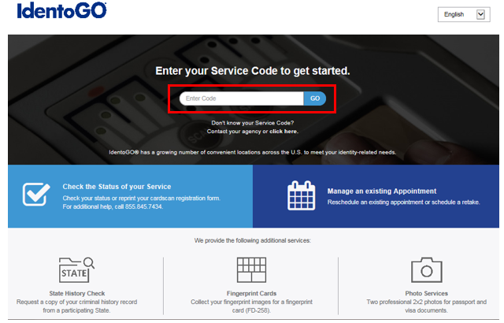

If you have **not yet** been provided a Service Code by the requesting agency, follow the link labeled “Don’t know your Service Code? Click Here” to select from a list of agency

names or use the agency ORI or contact your agency for assistance.

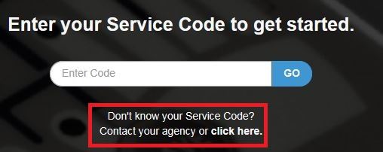

Please note: Not all agency ORI’s may be available with this look up tool.

**Please check with your agency, contributor, employer, or licensing administrator for specific information about Service Codes.**

1. The next screen is where you are going to select that you would like to submit a fingerprint card for processing.

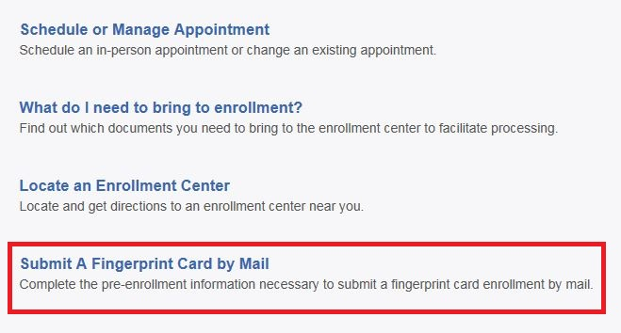

You will need to confirm that you are wanting to proceed with submitting a fingerprint card for processing. Click ‘Continue’ to proceed to the next page.

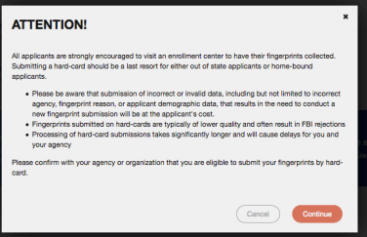

1. The next few screens will collect essential information such as name, date of birth, address, etc. You will need to complete all required information.
2. Pay for your service using an Authorization Code or Credit Card. If the Service is Auto-Billed to your Agency, payment will not be required.

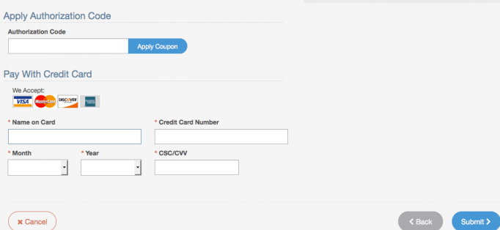

1. Once you have submitted your payment, you will be directed to the final registration page. You will need to complete sections 2 and 3 and submit this page along with your fingerprint card for processing. An example of the final screen is shown below.

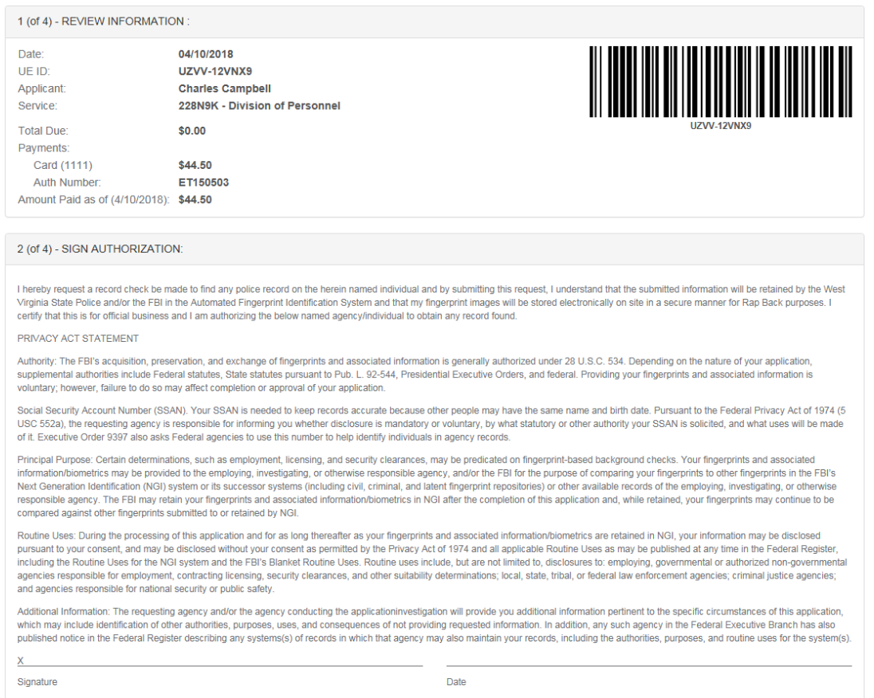

Sample Waiver

Language

Unique Applicant UE ID

x/xx/xxxx

Total Charged to Credit Card Credit Card Authorization Number Amount Paid

Applicant Name Service Code and Sample Agency

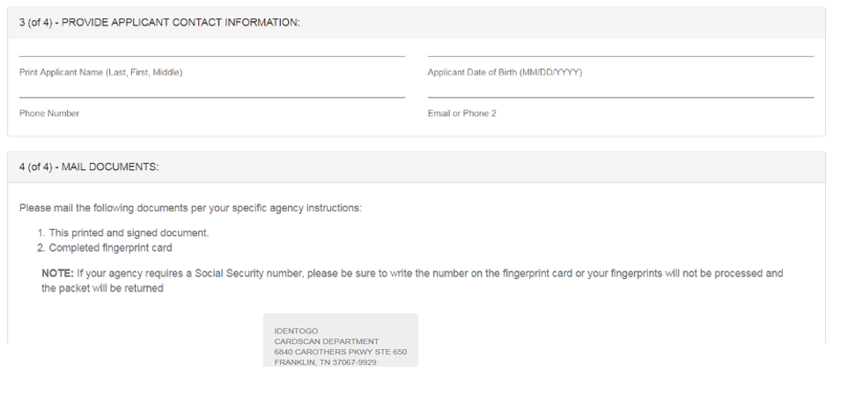

**Section 2 - Directions for Out-of-State Livescan Processing**

1. Visit [http://uenroll.identogo.com](http://uenroll.identogo.com/) and enter your 6-character Service Code assigned to the agency you plan to submit prints for, then click the **GO** button.



If you have **not yet** been provided a Service Code by the requesting agency, follow the link labeled “Don’t know your Service Code? Click Here” to select from a list of agency

names or use the agency ORI or contact your agency for assistance.



Please note: Not all agency ORI’s may be available with this look up tool.

**Please check with your agency, contributor, employer, or licensing administrator for specific information about Service Codes.**

1. The next screen is where you can select ‘Submit a Fingerprint Card by Mail’.

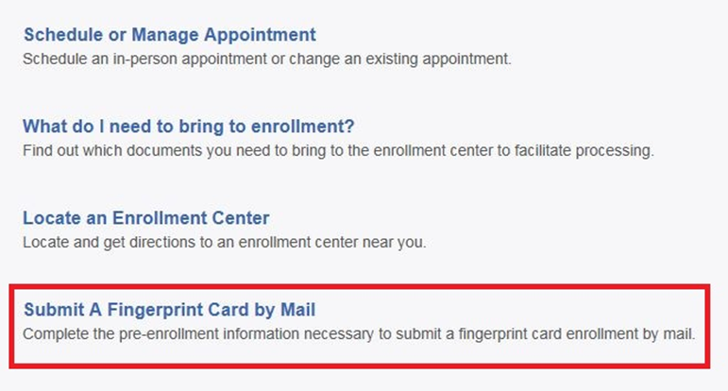

You will need to confirm that you are wanting to proceed with submitting a fingerprint card for processing. Click ‘Continue’ to proceed to the next page.



1. The next few screens will collect essential information such as name, date of birth, etc. You will need to complete the required information to progress.
2. Once you arrive on the below screen, you will need to click ‘Yes’ on “Would you like to locate the IdentoGO Enrollment Center nearest you?” question. This will allow you to proceed with viewing the closest IdentoGO Enrollment Center to you.

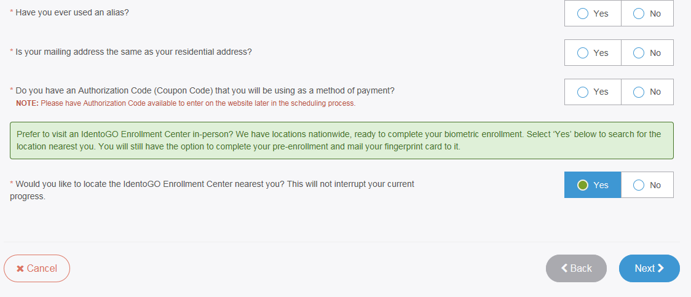

1. Continue the registration process by clicking on the Next button. You will continue to provide essesntial information such as height, weight, address, etc.
2. Once you arrive at the Location screen, you can enter your zip code and click on Search to find the nearest IdentoGO Enrollment Center to you.

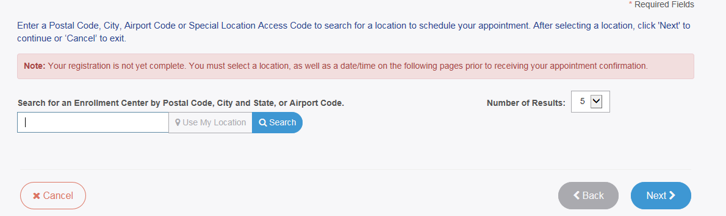

1. If you wish to proceed with scheduling an appointment at the nearest IdentoGO Enrollment Center, select the Enrollment Center and proceed with scheduling. If there is not an Enrollment Center in your area, you can click on the option to ‘Mail a Fingerprint Card’.

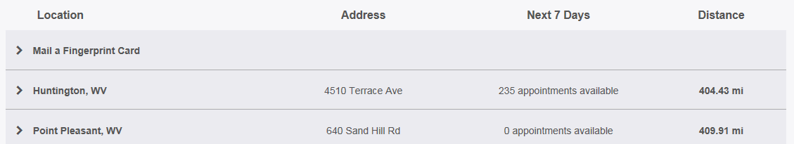

Any Town, USA Center Address Appointments Available XX mi

Any Town, USA Center Address Appointments Available XX mi

Selecting ‘Mail a Fingerprint Card’ will route you to the payment collection screen and provide you with your fingerprint card submission confirmation page. (See Section 1 above for further details and instructions.)

1. If you choose an Enrollment Center, you will then select a date and time for your appointment. Once you have selected your appointment details, you will then be routed to your appointment confirmation page. Please note that there is an additional fee for utilizing the Out-of-State LiveScan submission process.

